READ & UNDERSTAND
The Funny Family Photo - English / Class 4
Name: ______________________ Class: ________ Date: __________

1. Match the words with the meaning.
1. grandma | A. cane
2. camera | B. fiori
3. bouquet | C. mazzo di fiori
4. flowers | D. nonna
5. photo | E. fotografia
6. dog | F. macchina fotografica

2. True or false? Tick the correct box.
The family wants to take a photo. [ ] True [ ] False
Grandma holds a football. [ ] True [ ] False
Dad can set the camera timer. [ ] True [ ] False
Puddle takes Grandma's flowers. [ ] True [ ] False
The family is sad at the end. [ ] True [ ] False

3. Answer in English.
Who takes Grandma's flowers?
________________________________________________________________
Why is the photo funny?
________________________________________________________________

LET'S SPEAK ENGLISH
Use can and can't to talk about the characters.
Name: ______________________ Class: ________ Date: __________

4. Complete with CAN or CAN'T.
Grandma ______ hold the flowers.
Dad ______ set the camera timer.
Grandma ______ run fast.
Zara ______ help Grandma.
The family ______ stand still for the photo.

5. Who says it? Match the character to the action.
A. Zara 1. sets the timer
B. Dad 2. offers to help
C. Grandma 3. holds the flowers

6. Act it out with a partner!
Student A: Can you run fast?
Student B: Yes, I can! / No, I can't!
Now ask: Can you dance? Can you swim? Can you sing?

MY NEW COMIC PANEL
A funny ending: you are the comic author!
Name: ______________________ Class: ________ Date: __________

7. Draw what happens to the flowers next.

8. Write two speech bubbles in English.
Character 1 says: ___________________________________________________
Character 2 says: ___________________________________________________
CHALLENGE: Use CAN or CAN'T in your funny ending!

LOOK, POINT & SAY
Picture support - two short activities
Name: ______________________ Class: ________ Date: __________

1. Look and repeat.
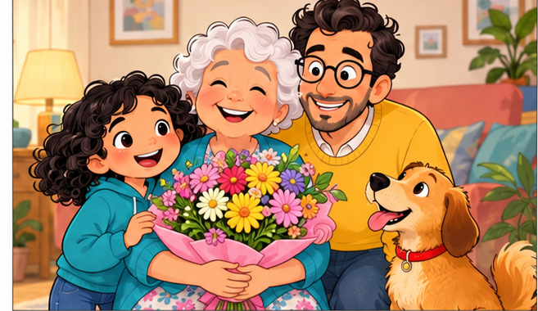 | 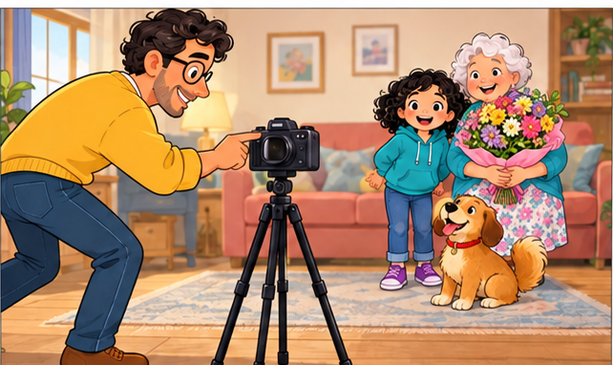 | 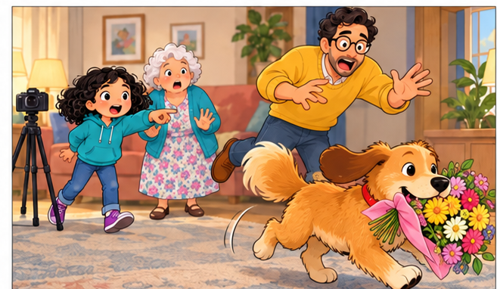
FLOWERS | CAMERA | DOG

2. Copy two words.
DOG __________________________________________________________

CAMERA _____________________________________________________

READ, CHOOSE & WRITE
Supported short sentences
Name: ______________________ Class: ________ Date: __________

1. Read and circle the correct word.
Dad has a ( camera / pencil ).
Puddle is a ( dog / cat ).
Puddle takes the ( flowers / camera ).
Zara can ( help / fly ).

2. Complete the mini-story.
Word bank: PHOTO DOG LAUGH
The family wants a _____________.
Puddle is the family _____________.
Everyone can ______________.

THE FUNNY PHOTO CHALLENGE
Talk, choose and invent!
Name: ______________________ Class: ________ Date: __________

1. Choose the best answer.
Who takes the flowers?
[ ] Zara [ ] Puddle [ ] Dad
What can Dad do?
[ ] Set the timer [ ] Fly [ ] Swim
How do they feel at the end?
[ ] Angry [ ] Sad [ ] Happy

2. Be a comedy writer.
Choose ONE funny idea: The dog returns the flowers / Dad sneezes / Grandma dances.
Zara: ______________________________________________________________
Dad / Grandma: ____________________________________________________

